THE VIEW OF THE TURKISH NETWORK MEMBERS OF THE ANNA LINDH FOUNDATION

Dr. Abdullah Orhan

- INTRODUCTION
The Anna Lindh Foundation (ALF) is a non-governmental organization that was established in 2005. Founded by 43 members of the Euro-Mediterranean Cooperation, the foundation supports civil society for the common future of the region and brings people together to develop intercultural cooperation in the Mediterranean. Its mission is to promote intercultural dialogue and mutual understanding between the people of the Mediterranean region. Among the subjects that the Foundation works on; are "education and youth", "culture and art", "peace and cooperation", "values, religion and spirituality", "cities and migration" and "media".
We conducted a survey to explore issues such as network members' purposes for networking, their plans for future work, their working areas and their perspectives on civil society. The Turkish ALF network currently has over 300 members in 2022, the survey on the Anna Lindh Foundation's perspective was applied to 50 of the 350 members of the Turkey Network.

2-SURVEY RESULTS OF THE VIEW OF THE TURKEY NETWORK MEMBERS TO THE ANNA LINDH FOUNDATION
In 2022, the survey on the Anna Lindh Foundation's perspective was applied to 50 of the 350 members of the Turkey Network. A total of 24 multiple-choice and open-ended questions were asked in the questionnaire and were evaluated by the IBM SSPS software.
50 network members participated in the survey. The answers given by the participants to the survey are as follows:
Question 1: What is the legal structure of your organization?
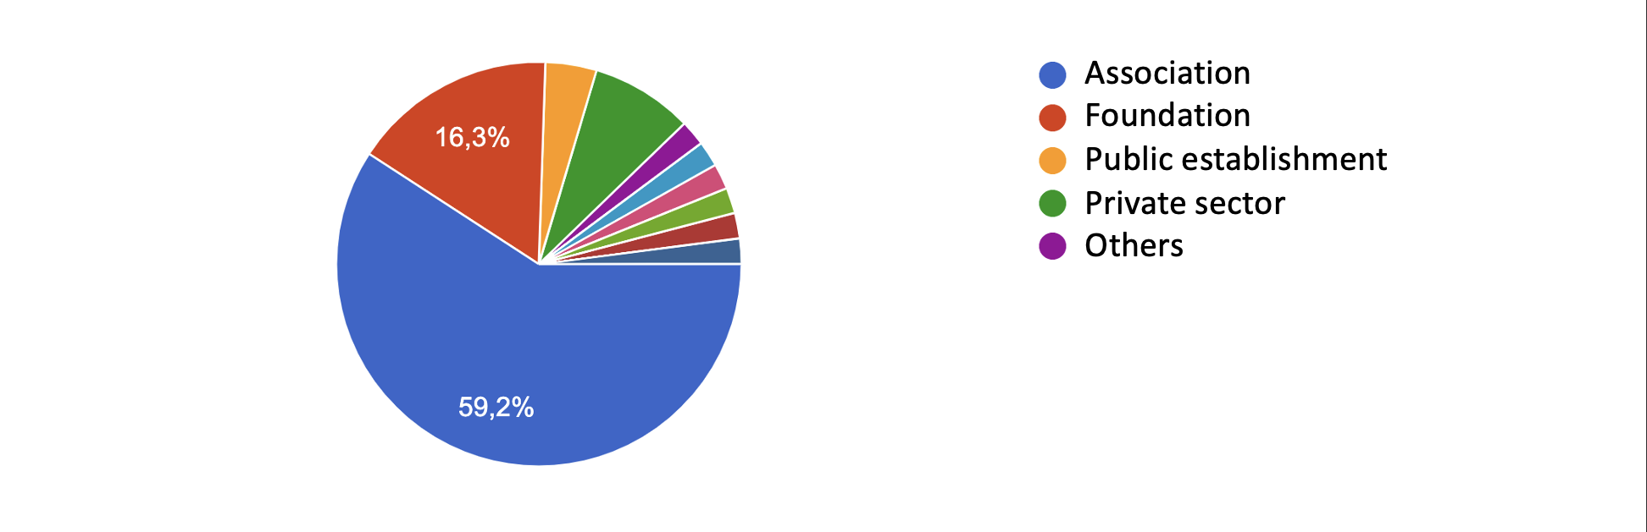
Most of the participants are associations and foundations. While the share of associations among the participants is 59.2%, the share of foundations is 16.3%.
Question 2: Which of the following statements describes the Anna Lindh Foundation best?
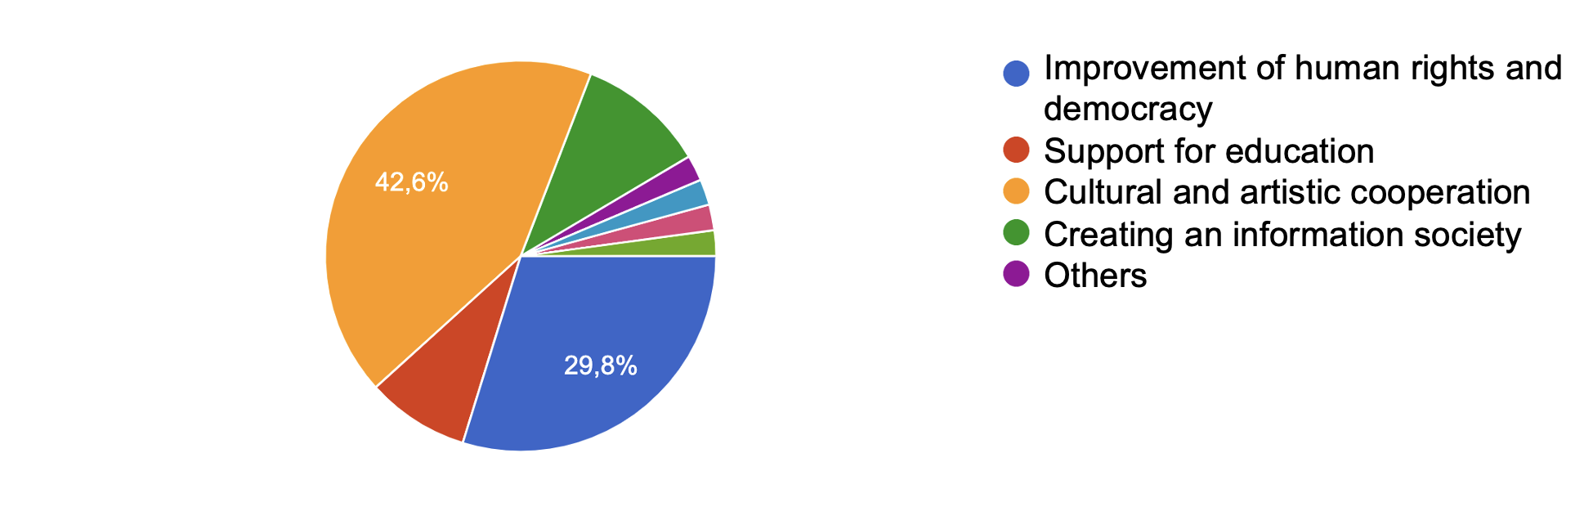
The majority of the participants (72.4%) preferred the options "Cultural and artistic cooperation" and "Development of human rights and democracy" among the expressions describing the Anna Lindh Foundation.
Question 3: What is the main purpose for your organization to become a member of the Anna Lindh Foundation?
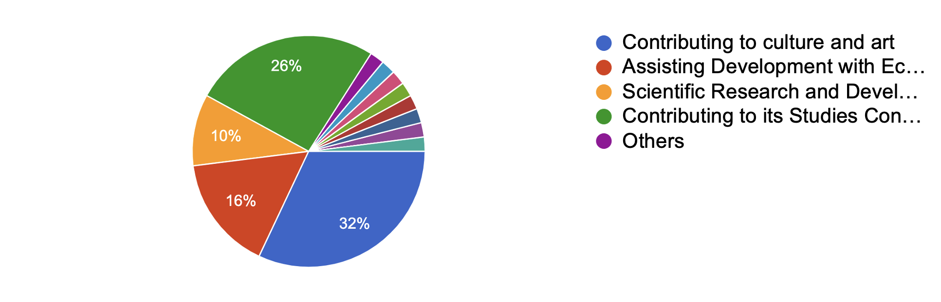
While 32% of the participants stated that the main purpose of being a member of the Anna Lindh Foundation is to "Contribute to culture and art", 26% chose "Contributing to the formation of an information society" and 16% preferred "Assisting development through economic cooperation".
Question 4: Do you have an activity that you are leading or co-organizing with other members for the purposes of the Anna Lindh Foundation?
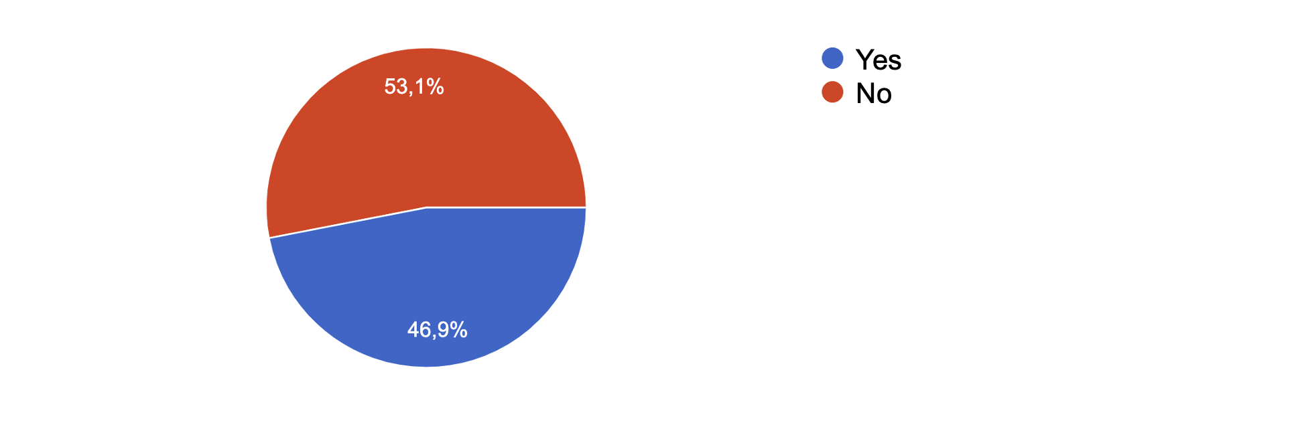
46.9% of the participants stated that they have activities that they pioneer or jointly organize with other members in line with the purposes of the Anna Lindh Foundation.
Question 5: If your answer is yes, which of the following activities do you join?
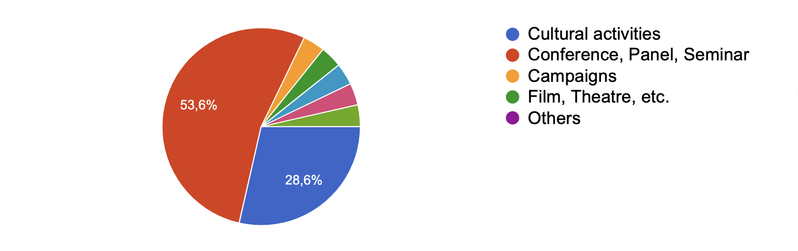
The majority of the participants (82.2%) stated that the activities they pioneered or organized jointly with other members in line with the purposes of the Anna Lindh Foundation are conferences, panels, seminars and cultural activities.
Question 6: What type of project do you plan to carry out in the future?
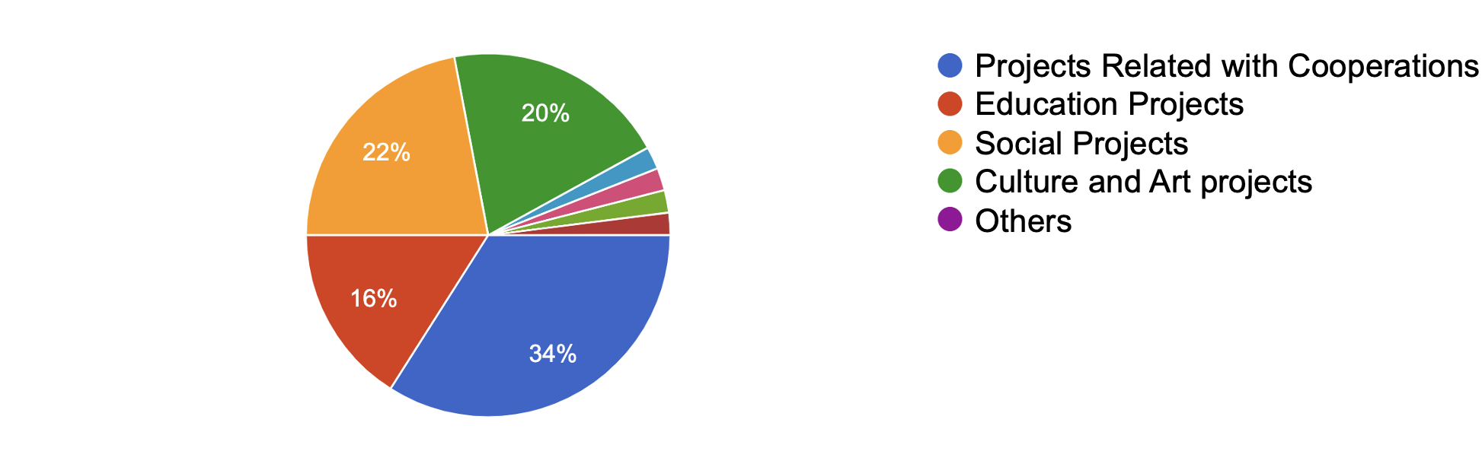
Participants stated that they plan to carry out projects with collaborations, culture-arts, education, and social content in the future.
Question 7: Do you work in communication or advocacy campaigns, informative videos, newsletters, or intercultural values ​​and principles?
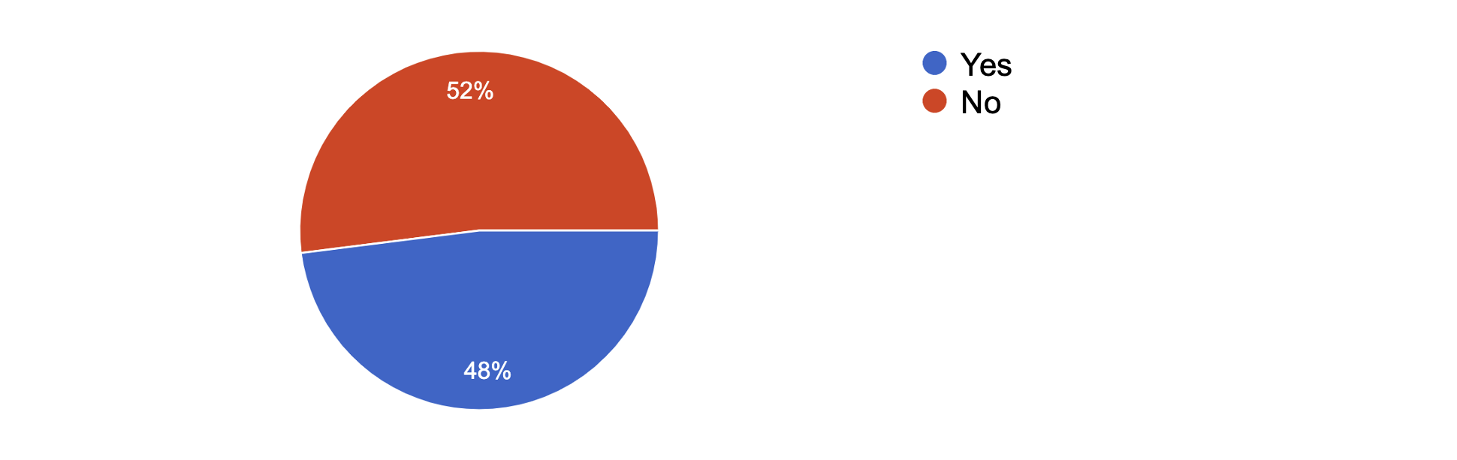
48% of participants stated that they work in communication or advocacy campaigns, informative videos, newsletters, or work in the field of intercultural values ​​and principles.
Question 8: Have you done any field research on organizational culture and performance management systems before?
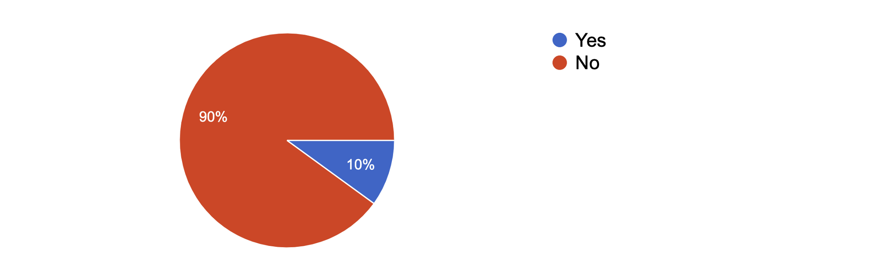
Most of the participants stated that they had not done field research on organizational culture and performance management systems before.
Question 9: Can you develop cooperation with public authorities to ensure coordination between national and Euro-Med regional policies?
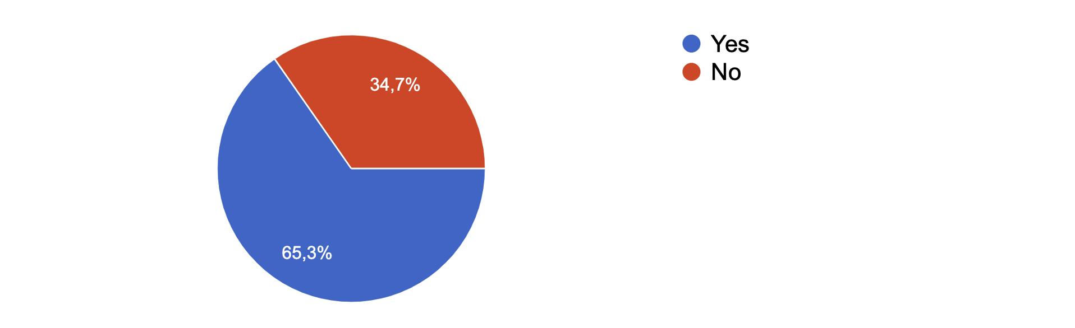
Most of the participants stated that they can develop cooperation with public authorities to ensure coordination between national policies and Euro-Med regional policies.
Question 10: Do you have any projects that address and contribute to gender equality?
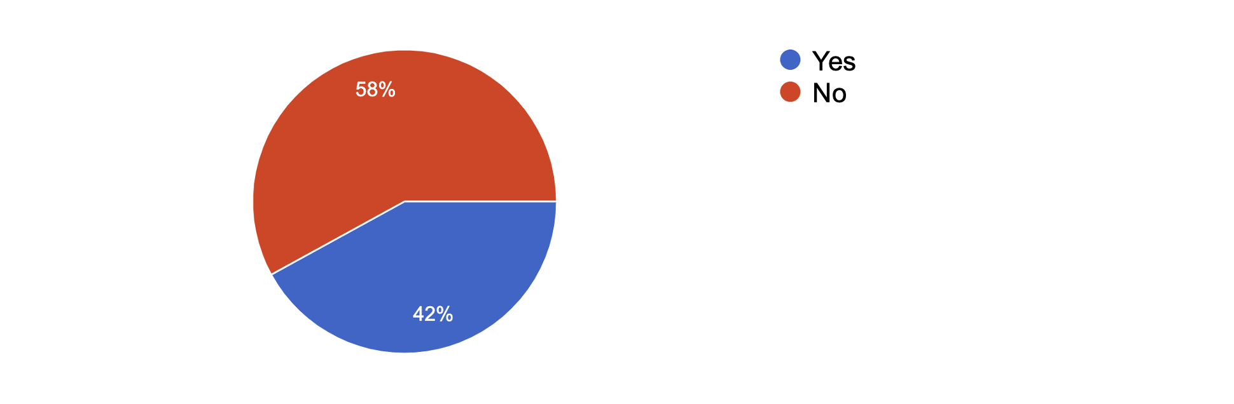
More than half of the participants stated that they have projects that address and contribute to gender equality.

Question 11: Do you have any work on "Climate Change", one of the sustainable development goals?
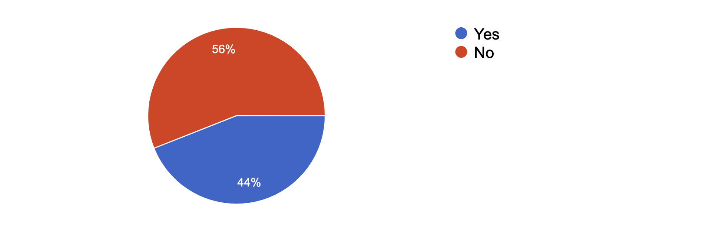
Most of the participants stated that they had not done any study on climate change before.
Question 12: Have you implemented any projects that promote or contribute to Social Inclusion as a way to avoid inequalities?
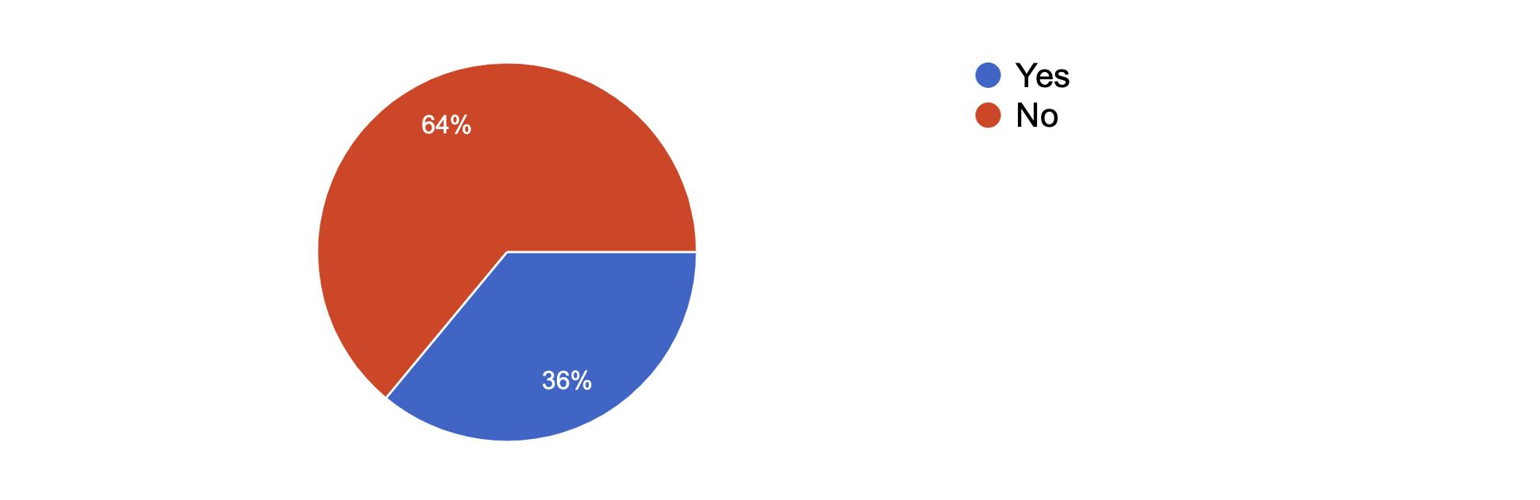
Only 36%of participants have implemented projects that promote or contribute to Social Inclusion as a way to avoid inequalities.
Question 13: Have you worked on a project on “Hate Speech”?
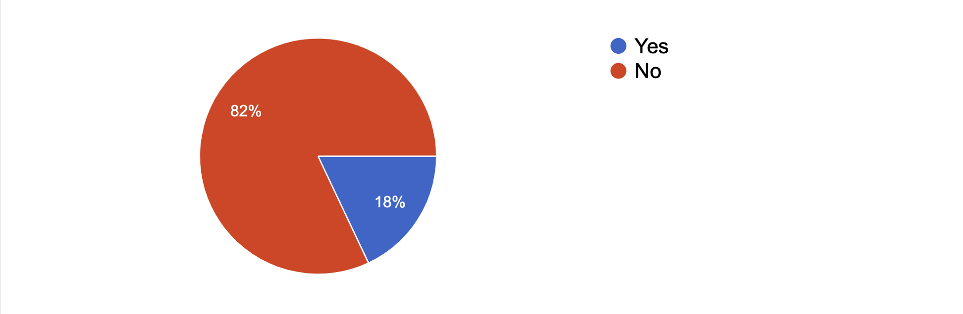
Only 18% of participants have worked on a project on “Hate Speech. Most of the participants stated that they had not done any research on hate speech before.

Question 14: Have you done any capacity-building studies in the field of "cultural cooperation and communication"?
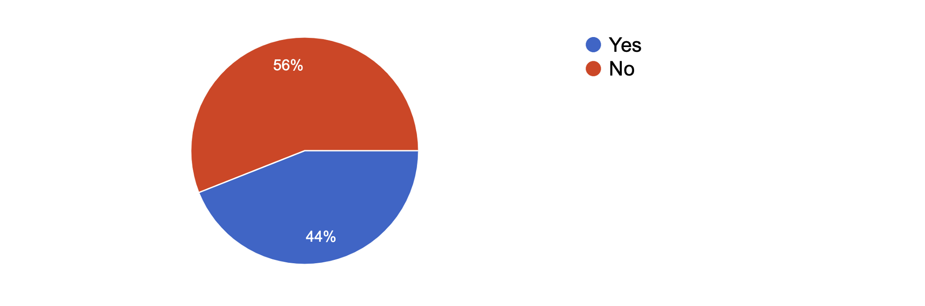
44% of participants have done capacity-building studies in the field of "cultural cooperation and communication
Question 15: Can you contribute to developing stage performances or mobility activities that promote intercultural interaction, any aspect of culture and creativity as a shared heritage, or based on social inclusion in the field of Euro-med?
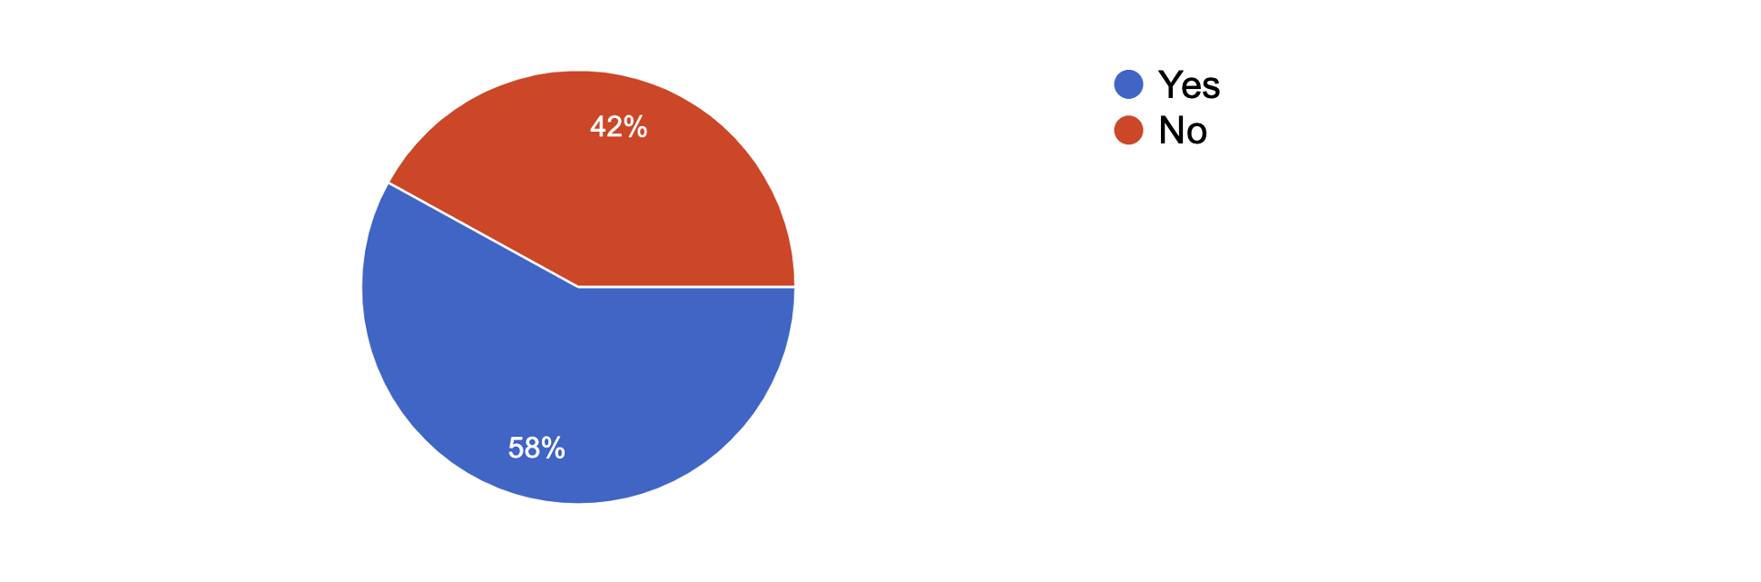
58% of participants stated that they can contribute to develop stage performances or mobility activities that promote intercultural interaction, any aspect of culture and creativity as a shared heritage, or based on social inclusion in the field of Euro-med.
Question 16: How can work on climate change be promoted?
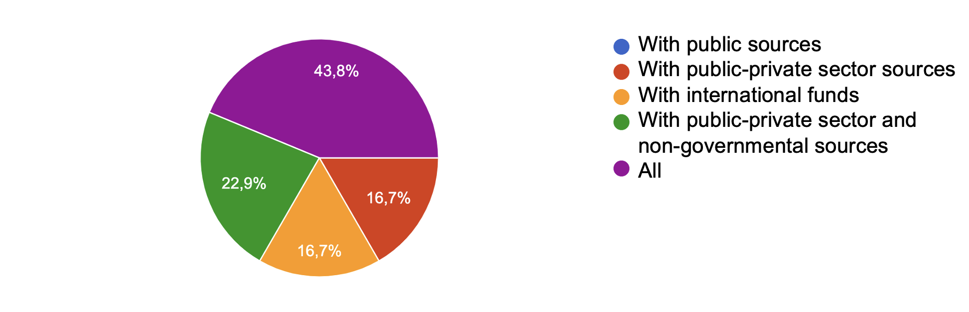
The majority of the participants stated that studies on climate change can be encouraged with the contribution of public, private sector and non-governmental resources and national funds.
Question 17: How can you collaborate with public authorities to develop national and regional policies?
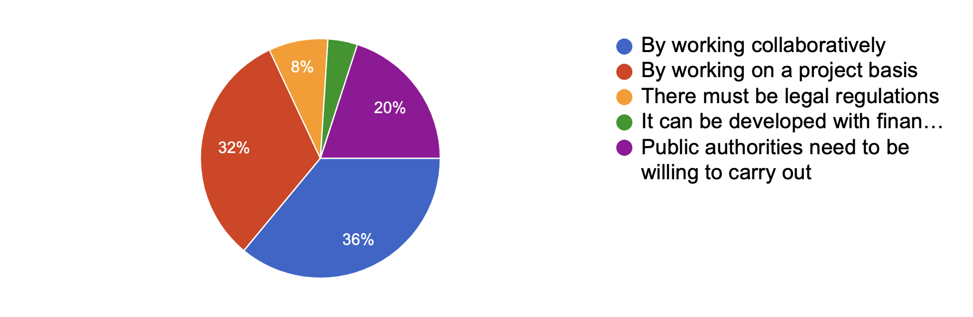
Most of the participants stated that they can develop joint and project-based collaborations with public authorities to develop national and regional policies.
Question 18: How do you evaluate the actions of NGOs that address and contribute to gender equality in Turkey?
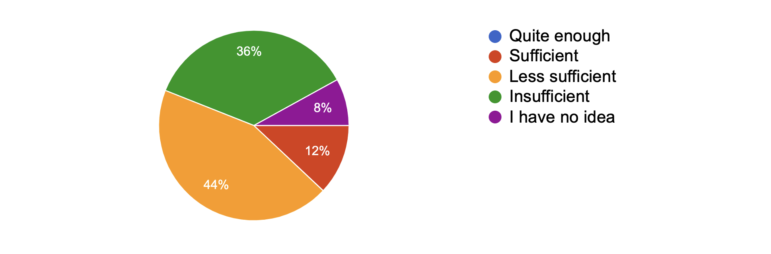
The general opinion of the participants (80%) is that the actions of CSOs in Turkey that address and contribute to gender equality are not at an adequate level.
Question 19: How do you expect your membership to the Anna Lindh Foundation to contribute to you in the future?
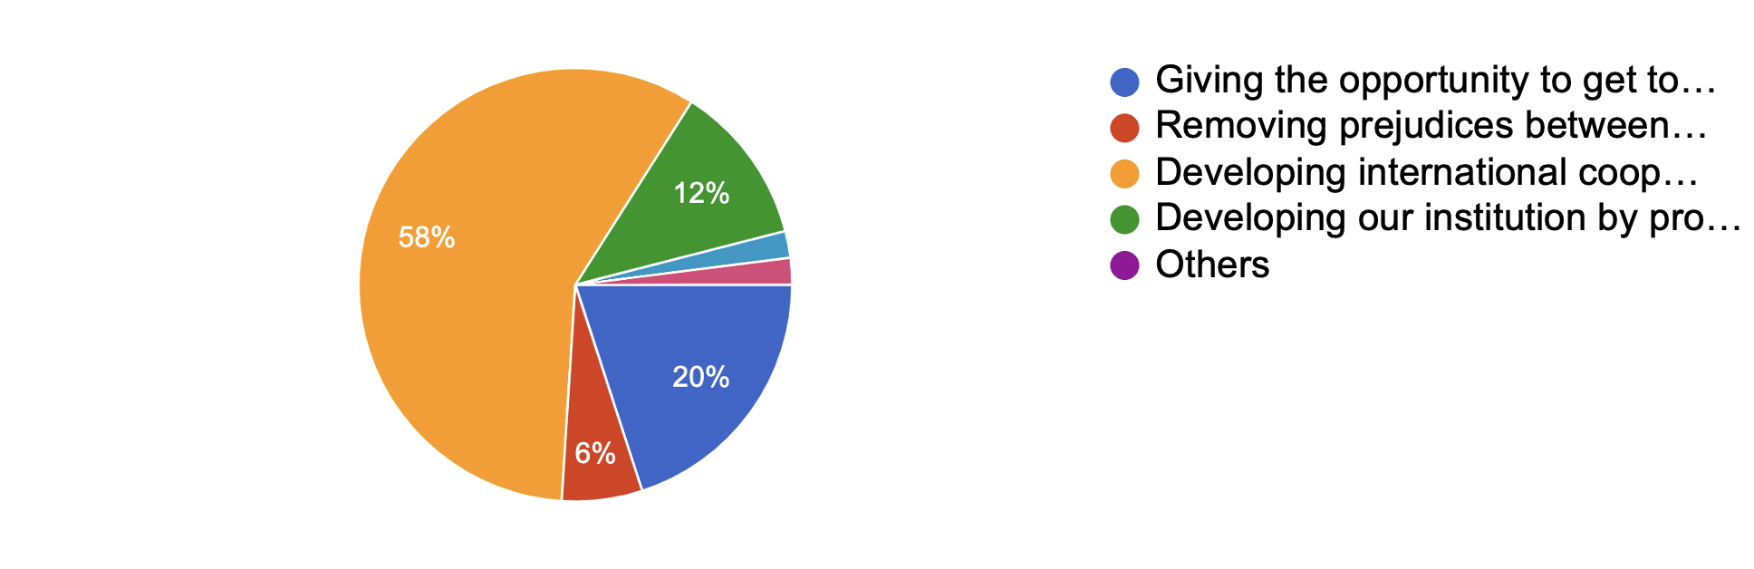
The majority of the participants (78%) expect their membership in the Anna Lindh Foundation to contribute to their future opportunities to develop international cooperation and get to know different cultures.
Question 20: As a member of the Anna Lindh Foundation, in which field do you expect support for the implementation of projects?
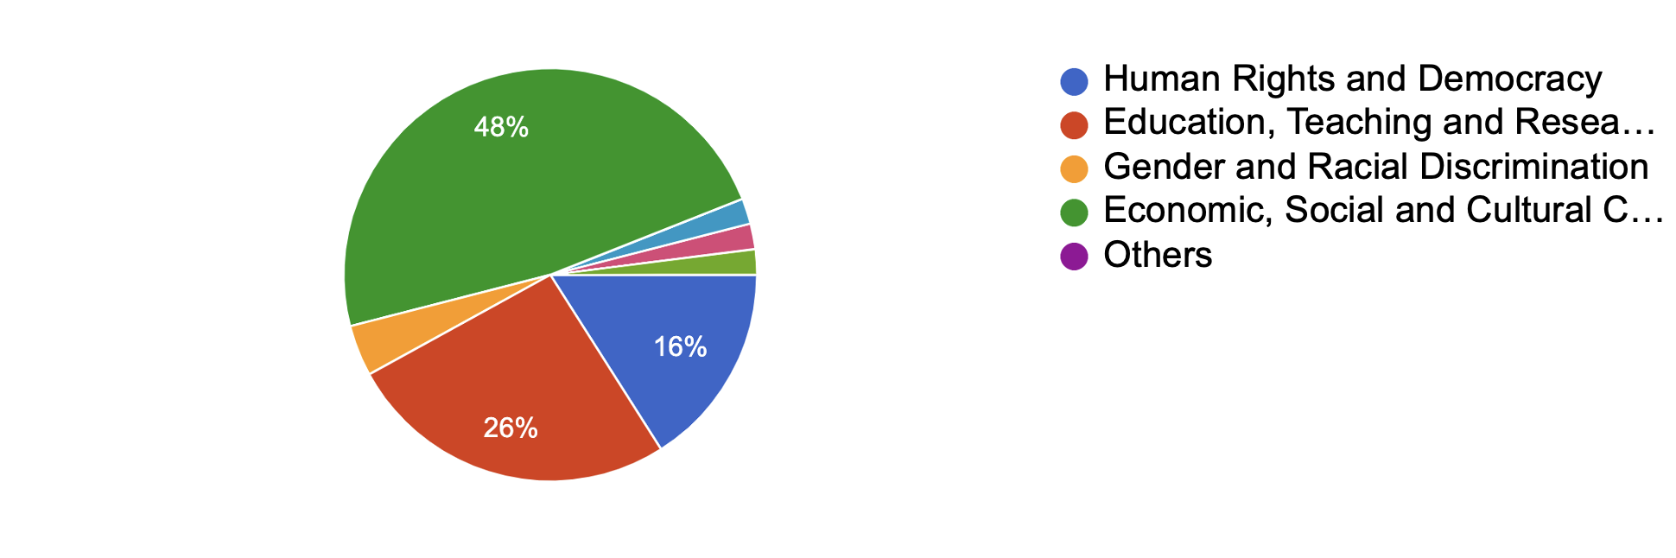
48% of the participants stated that they expect support for the implementation of projects in the field of "Economic, Social and Cultural Cooperation", 26% "Education, Training and Research", and 16% "Human Rights and Democracy".
Question 21: If you were to submit a project proposal to the Anna Lindh Foundation, which one would you choose?
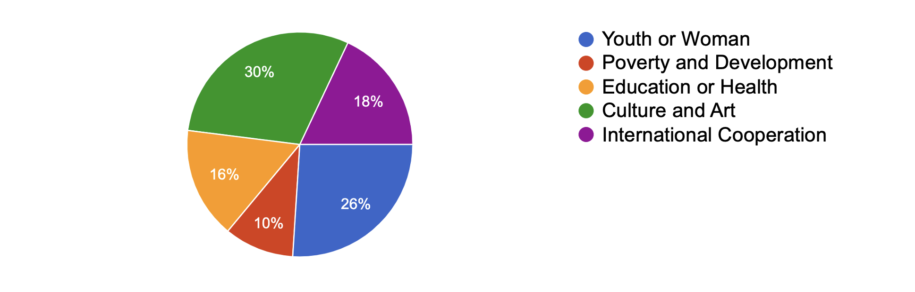
The majority of the participants (56%) stated that if they were going to submit a project proposal to the Anna Lindh Foundation, it would be about “culture and art” or “youth or women”.

Question 22: Would you like to participate in a project to find a solution to the negative developments between the Mediterranean countries?
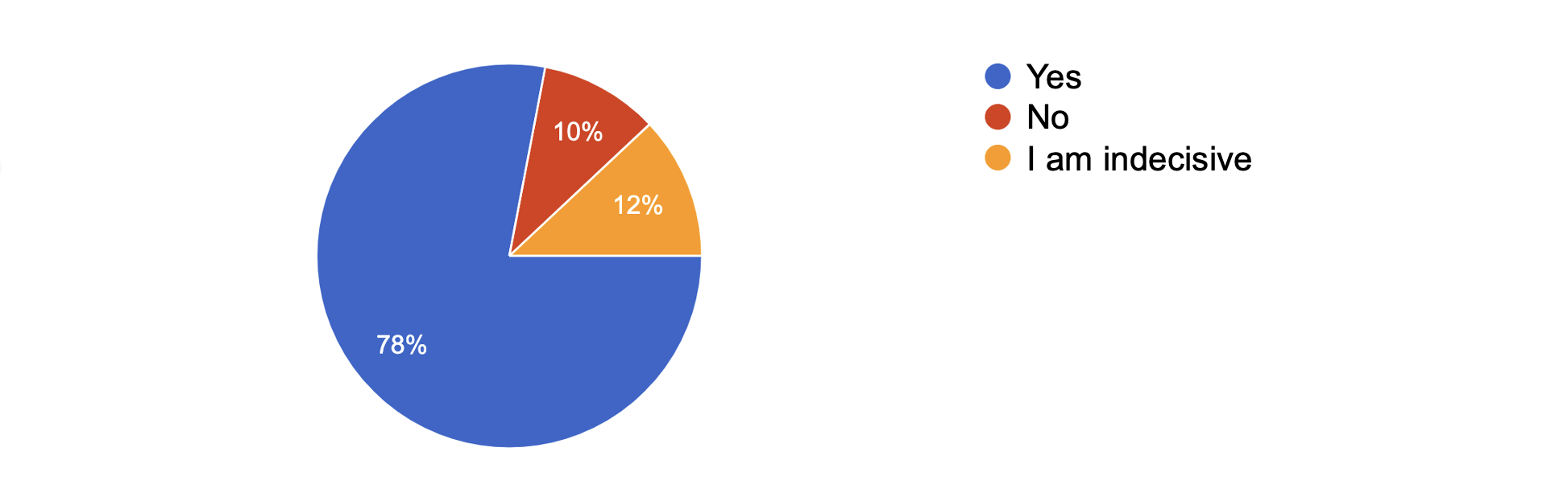
The vast majority of the participants (78%) stated that they would like to participate in a project to be carried out to find a solution to the negative developments among the Mediterranean countries.
Question 23: Do you plan to organize a national event with other members of the Anna Lindh Foundation in Turkey? 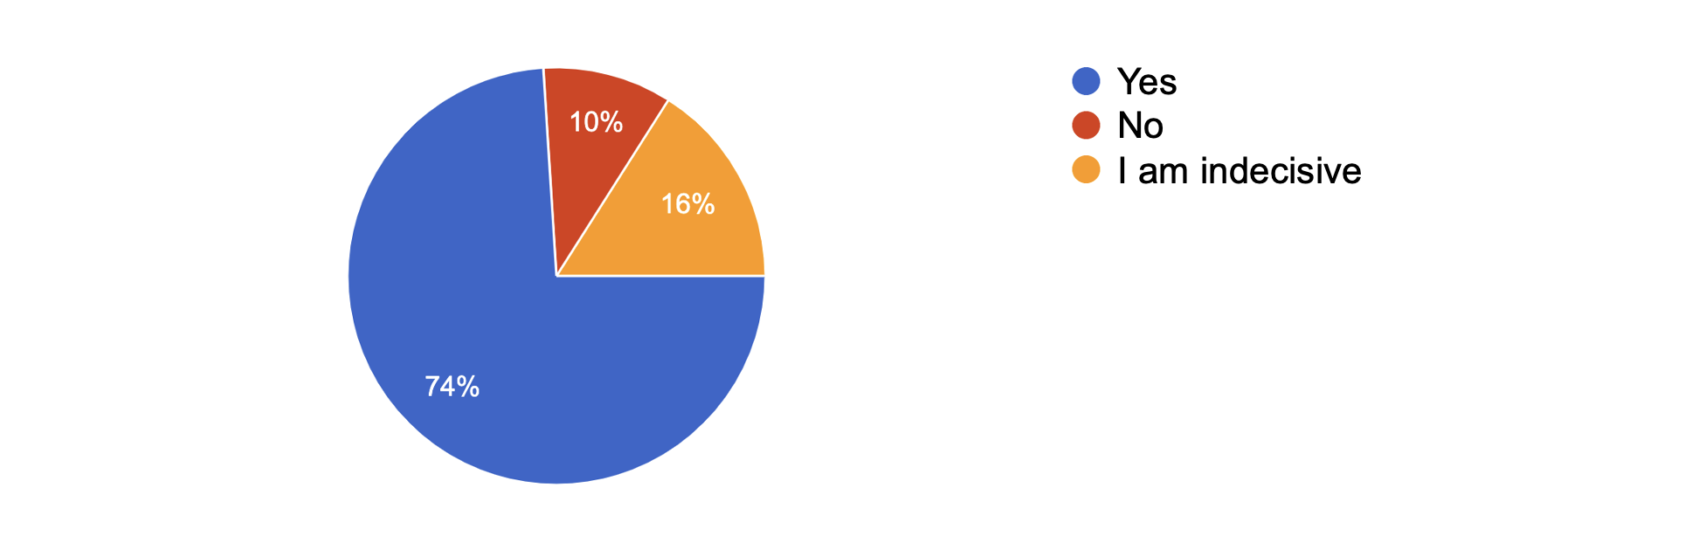
The vast majority (74%) of the participants stated that they were considering holding a national event with other members of the Anna Lindh Foundation in Turkey.
Question 24: Are you aware of other members of the Anna Lindh Foundation in Turkey?
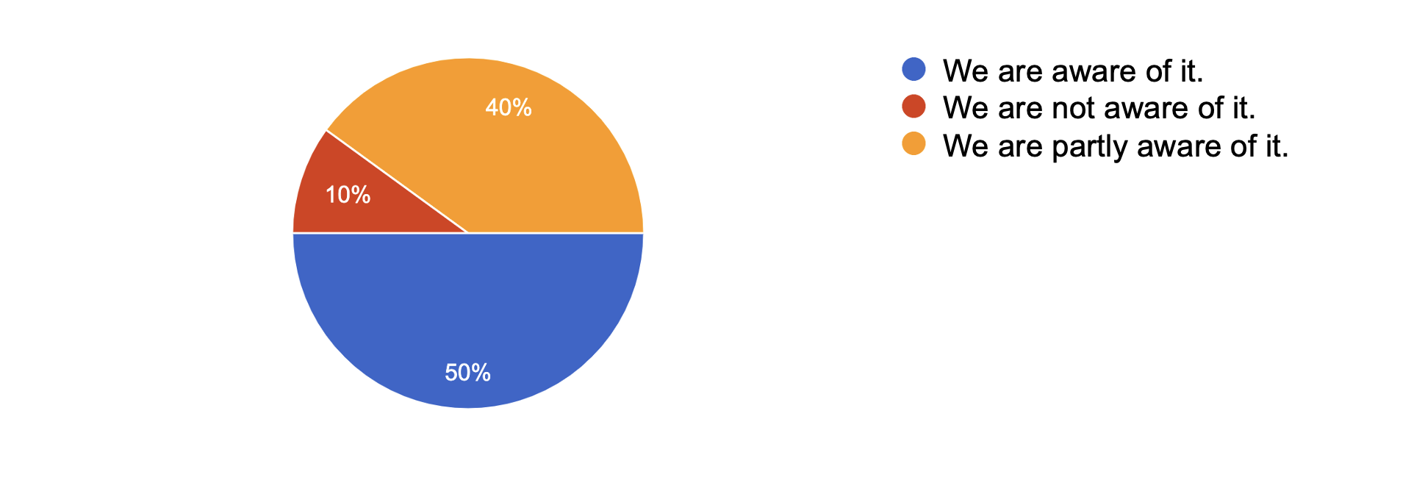
Half of the participants stated that they were aware of the other members of the Anna Lindh Foundation in Turkey, while 40% stated that they were partially aware.

3. CONCLUSIONS
We made a survey on the Anna Lindh Foundation's perspective that was applied to 50 of the 350 members of the Turkey Network in 2022. It shows where intercultural dialogue is needed more than ever. The survey results are summarized below:
- Most of the participants are associations and foundations.
- Most of the participants describe ALF as "cultural and artistic cooperation".
- Participants plan to carry out projects with collaborations, culture-arts, education, and social content in the future.
- Only a few of the participants have done field research on organizational culture and performance management systems before.
- Most of the participants stated that they had not done any studies on climate change before.
- More than half of the participants stated that they could contribute to develop stage performances or mobility activities for ALF activities.
- The majority of the participants stated that studies on climate change can be encouraged with the contribution of public, private sector and non-governmental resources and national funds.
- Participants expect "international cooperation", "economic, social and cultural cooperation" and "projects in the fields of culture, art, women and youth" from the ALF network.
- Most of the participants stated that they would like to participate in projects and events organized by ALF.
We think that the ALF remains an important platform that can contribute to the development of dialogue between people in the European Mediterranean region. It will be useful to benefit from and contribute to the work of the foundation as much as possible. There is a difference between people's environmental awareness and values and the level of sensitivity decreases as the level of education and income decrease. In short, it was concluded that the higher the education level, the higher the environmental values.

Gumushane University in Turkey

